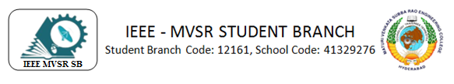
IEEE MVSR CS SB General Body Meeting(GBM)
The newly appointed Executive committee of IEEE Computer Society(CS) Student Branch convened for a general body meeting on 22nd July 2023 to set the agenda for the events to be conducted in the year to promote learning and innovation of the students.
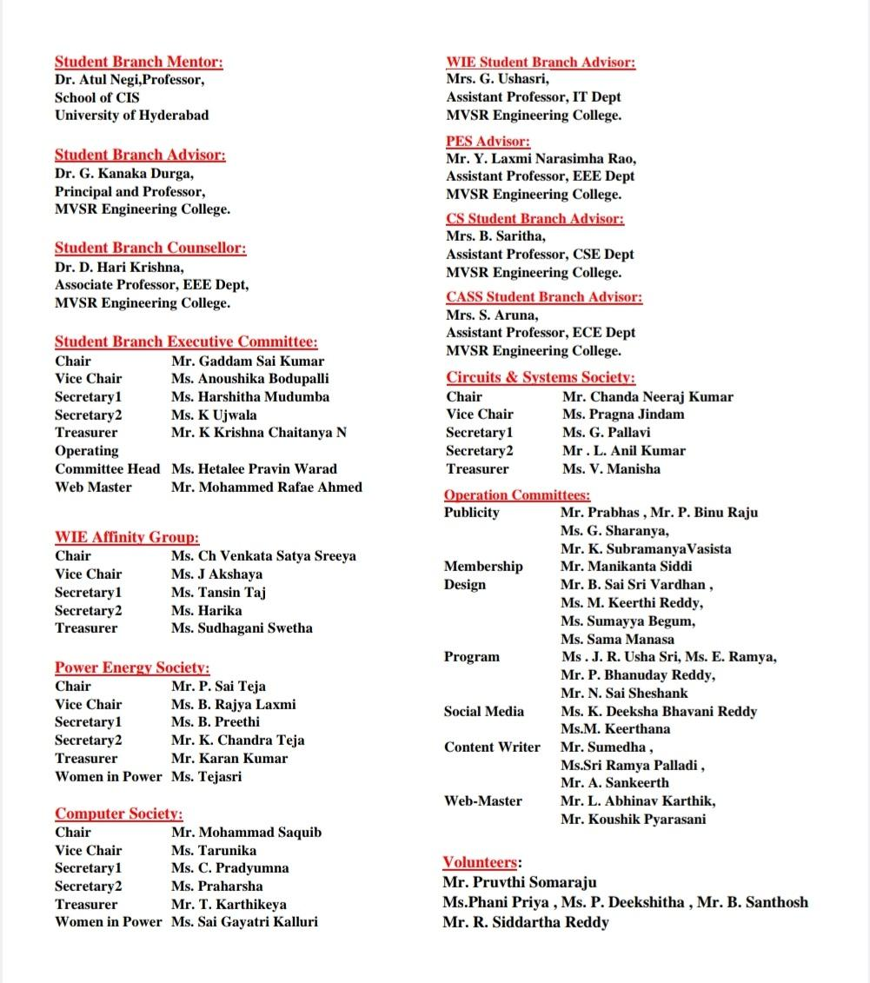

Session Details:
Date: 22nd July 2023
Timings: 7:30 PM-9:00 PM
Speaker for the session: Mohammad Saquib (IEEE MVSR CS Chair)
Description:
The newly appointed Executive committee of IEEE Computer Society(CS) Student Branch convened for a general body meeting on 22nd July 2023 to set the agenda for the events to be conducted in the year to promote learning and innovation of the students.
The meeting started with Dr .D. Harikrishna sir’s speech which encouraged the newly appointed IEEE CS executive committee members to be proactive in conducting IEEE events. He stressed upon the importance of being an active participant in the events of the student branch as appointed members. He said that as executive committee members, it is our duty to promote participation in IEEE technical events and help in the growth of students which will help them in their professional careers. He outlined the timeline of events for the academic year 2023-24, starting from first week of September to June 2024. His speech enabled the students to understand their roles as IEEE CS executive committee members and renewed their determination in organising events for the students.
The meeting then proceeded with the events to be conducted in the year, presented by IEEE CS Chair Mohammad Saquib. He went on to talk about the various technical events to be conducted, starting with a comprehensive Cybersecurity Bootcamp to be held in September in collaboration with Cyber Ekta, a leading Cybersecurity company. The bootcamp will spread awareness about the much needed security of data on the cloud architecture, and will educate students on the domain of cybersecurity from beginning to advanced. This will enable the students to gain real world application skills and promote their professional careers.
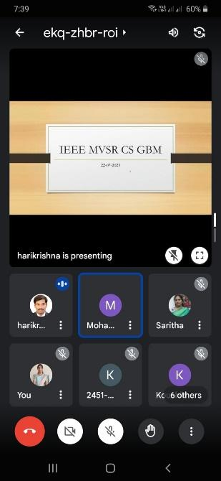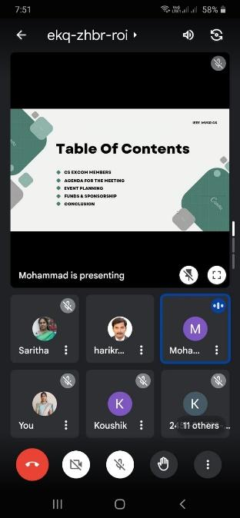
Screenshots from the meeting
He stressed the importance of IEEE Xtreme 17.0, the global 24-hour coding competition which has participation in the tens of thousands including students from all over the world. He advised the other members to spread awareness about the same and discussed a few ideas to help students prepare so that they perform better in the competition. He stressed on the importance of problem solving and data structures, and inculcate them in students’ by a collaborative effort.
The Vice Chair, T Tarunika, went on to talk about the different events to be conducted for the benefit of the students, so that they are aware of the real world trends in the global market. She highlighted the importance of webinars and seminars, which are an excellent avenue for students to gain an understanding of the current demand for a skilled professional market. She even spoke about the different social outreach programmes that could help the less privileged youth in the locality. As students pursuing professional courses, everyone recognized the importance of education and agreed to be active in the outreach programmes.
The Chair encouraged the other members to participate by giving new ideas or pointers to improve on existing ideas and how to better implement the plan. The executive committee members enthusiastically came up with effective ideas to better implement the agenda. IEEE main student branch chair and vice chair, and IEEE faculty coordinators Mrs. B. Saritha and Mrs.G.Ushasri who were also present in the meet, gave inputs to the members.
The meeting ended on a high note with a vote of thanks by IEEE CS Vice Chair, T Tarunika, with various administrative tasks assigned to the members, who were enthusiastic to organise the IEEE events.

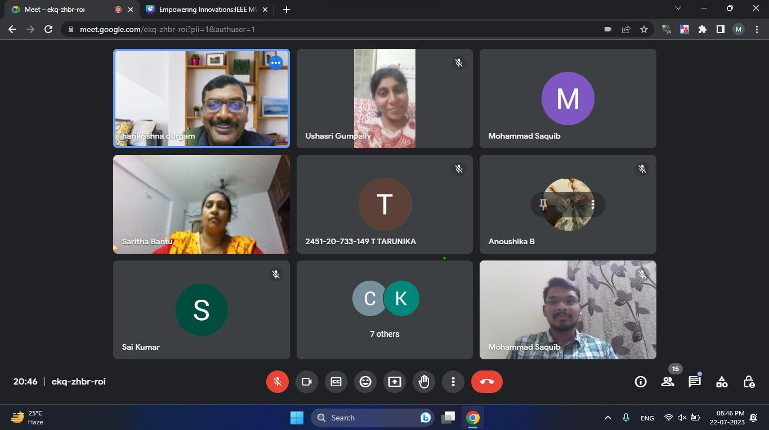
Screenshots from the meeting

List of Attendees:
Dr. D. Harikrishna
Mrs. B. Saritha
Mrs. G. Ushasri
2451-20-735-069 - Gaddam Sai Kumar
2451-20-733-037 - Anoushika Boddupalli
2451-20-733-132 - Mohammad Saquib
2451-20-733-149 - T Tarunika
2451-21-733-066 - Chacham Pradyumna
2451-21-737-170 - Nelaturi Praharsha
2451-20-733-152 - Thimirishetty Karthikeya
2451-21-733-118 - Kalluri Sai Gayathri
2451-20-733-162 - Mohammed Rafae Ahmed
2451-21-733-083 - Koushik Pyarasani
2451-20-733-025 - Sumayya Begum
2451-20-735-064 - Akshaya Jureddy

